Ofsted Reg. No.108416
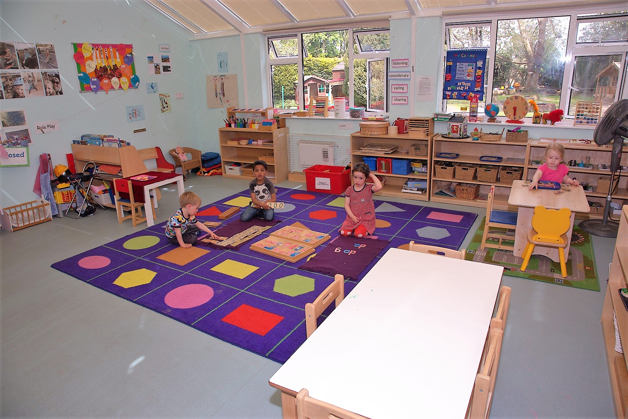
School Lane, Littlewick Green, Maidenhead, SL6 3QY
E-Mail:manager@lgmontessori.com Tel/Fax: 01628 828258 www.lgmontessori.com
FREE EDUCACION FUNDING HOURS FOR CHILDREN 3+
- To receive the full 15 hours of free entitlement, children should attend a minimum of five sessions a week. The free education starts the term after the child’s third birthday. Please ask for a fee estimate with funding.
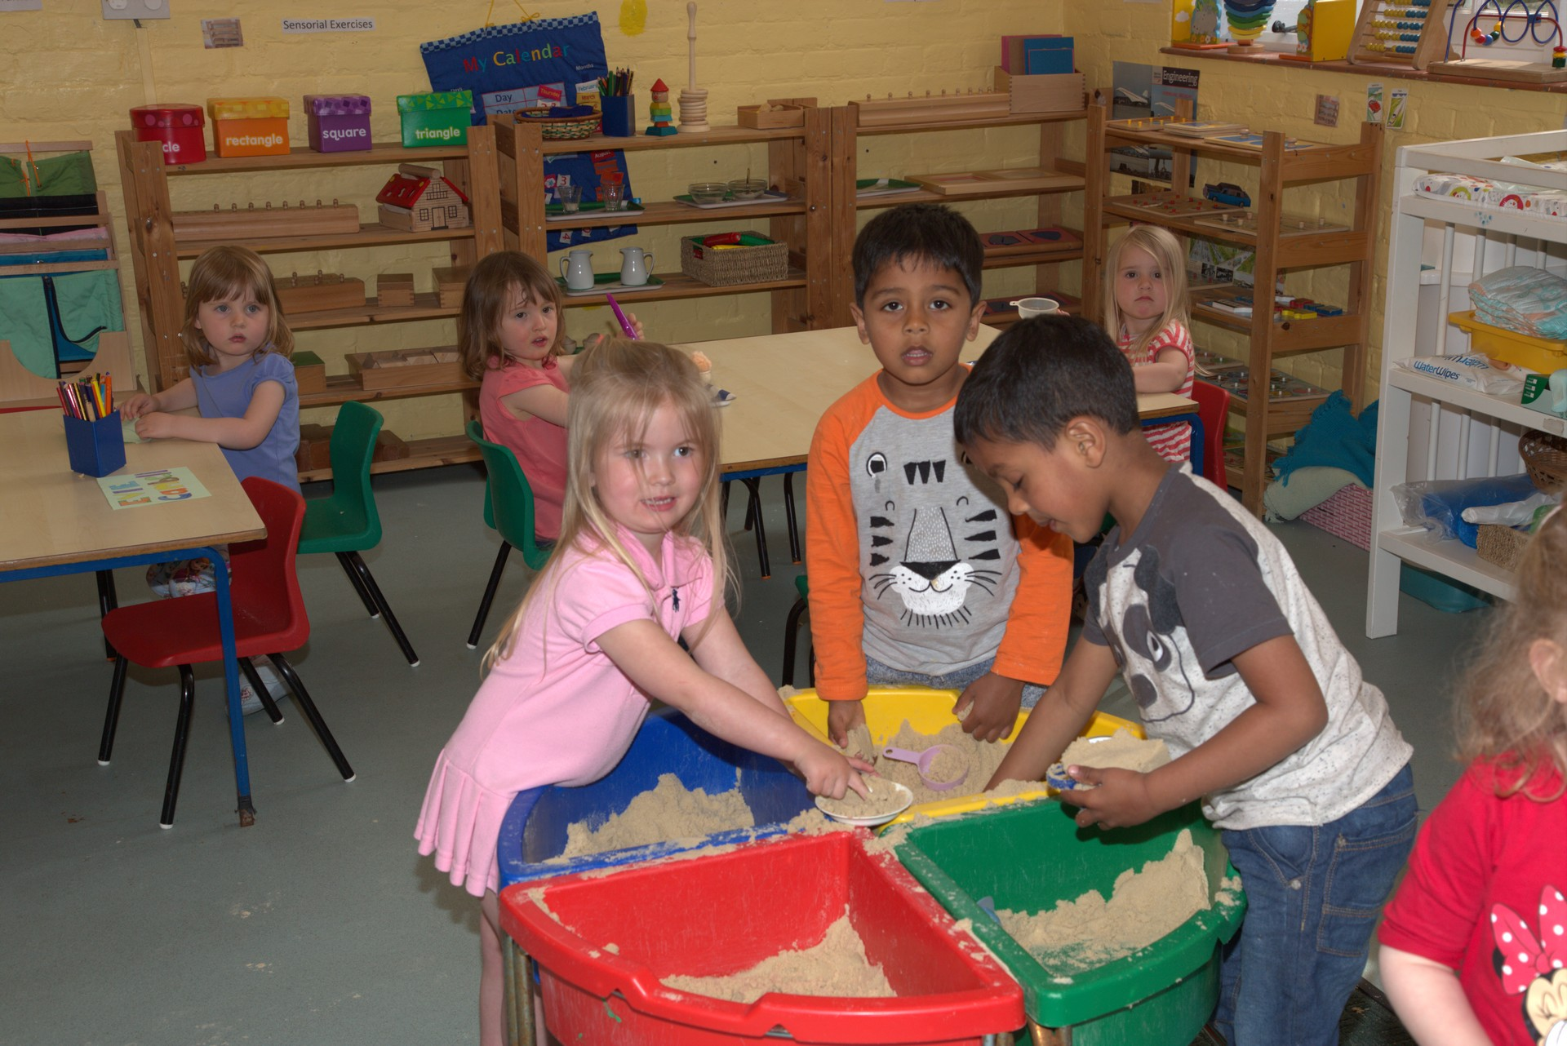
- Parents with children eligible for the free nursery education should pay for all snacks, meals, drinks, nappies and material.
- You can use your funded hours over the 38 weeks of the school year and pay private fees during school holidays or you can spread your funding hours across the 12 months of the year and pay a smaller fixed monthly fee (example: children attending five sessions or more could take up to their full 570 hours’ annual entitlement, receiving 47.5 hours of free education per month.)
- To receive the full 15 hours of free entitlement, children should attend a minimum of five sessions a
- Please ask for a fee estimate with funding hours (example of a monthly invoice).
Sessions | Fees payable by the parent and free hours
Half day (8-1) or (1-6) | £21.46 – 3 hours
School day (8-4) | £24.92 – 6 hours
Full day (8-6) | £31.92 – 6 hours
Free session only (8:30-11:30 or 1:00 to 4:00) | £3.00
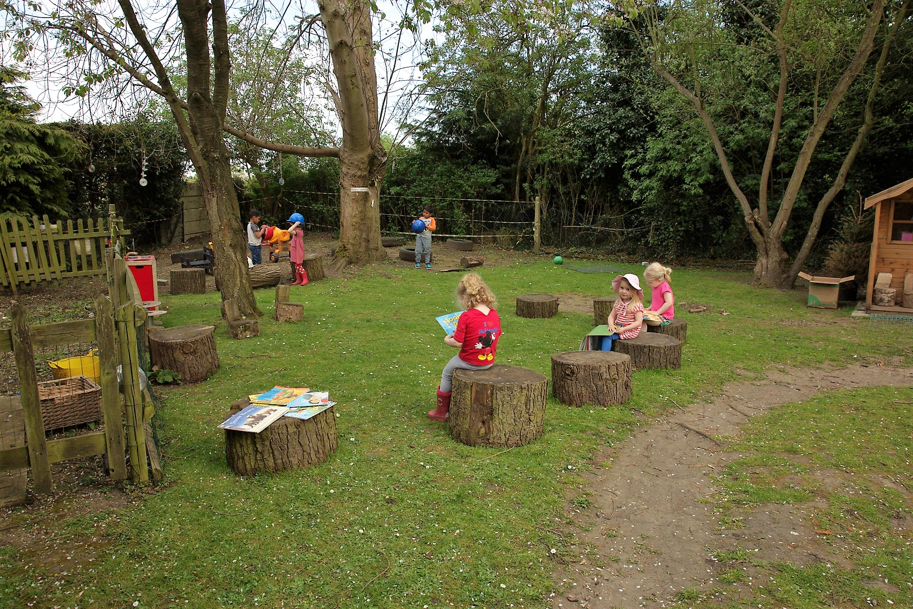
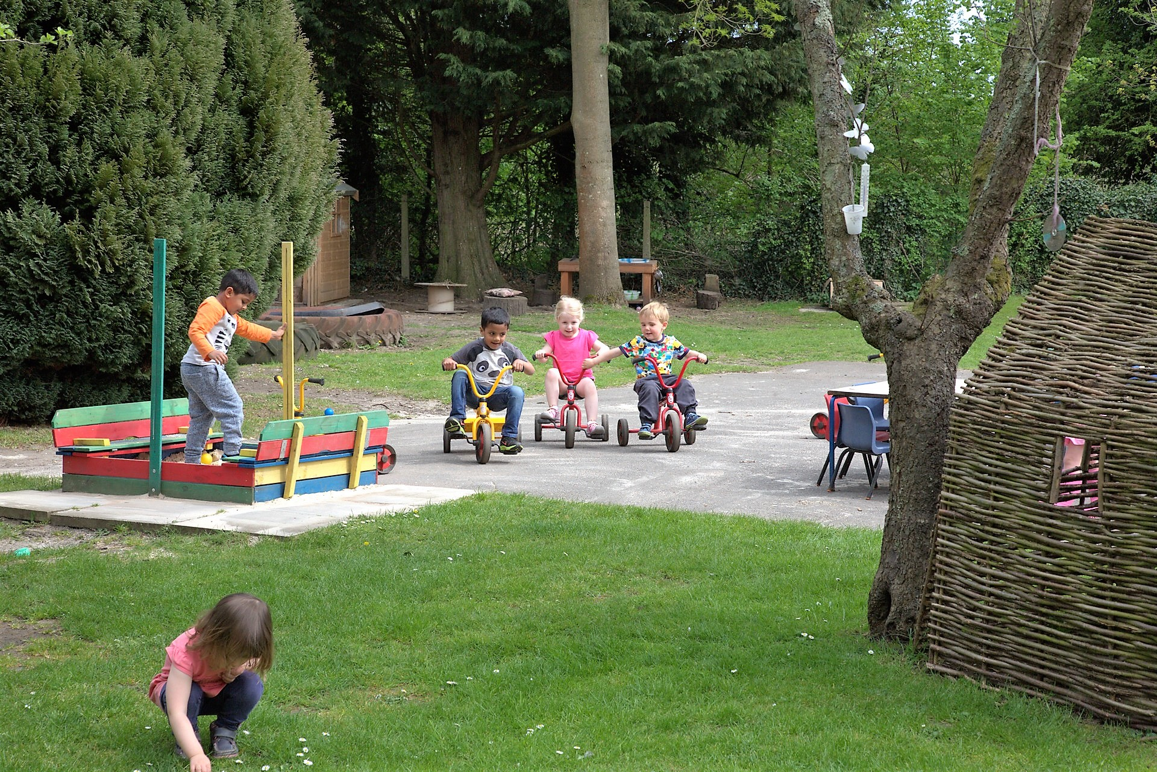
- Deposit: £100 per child. Refundable at the end of the agreement. Fully funded places don’t pay registration fee.

