Week 1 and 3
Time | Monday | Tuesday | Wednesday | Thursday | Friday
Snack  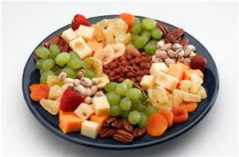 | Crackers and cream cheese | Rice cakes and apples | Breadsticks and pears | Grapes and orange segments. | Cheese and cucumber sticks.
Lunch  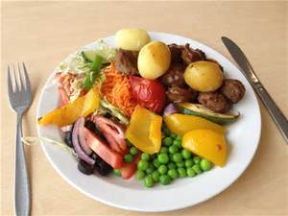 | Sweet and sour chicken and rice. | Rainbow macaroni cheese. | Cowboy casserole. | Fish cakes, potatoes and beans. | Spaghetti bolognaise.
Veggie Option  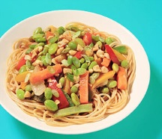 | Quorn chicken and rice with sauce. | Rainbow macaroni cheese. | Quorn sausage casserole. | Quorn chicken/fish cakes, potatoes and beans. | Quorn mince bolognaise and pasta.
Pudding  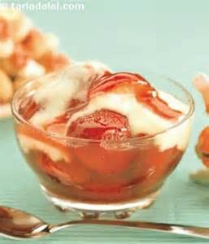 | Yoghurts | Flap jacks | Melon | Rice pudding. | Bananas with Custard
Snack  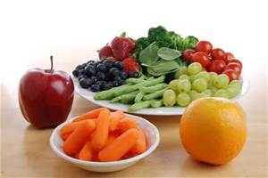 | Banana and apple. | Grapes and orange segments. | Crackers and cheese. | Rice cakes and pears. | Carrot and cucumber sticks.
Tea  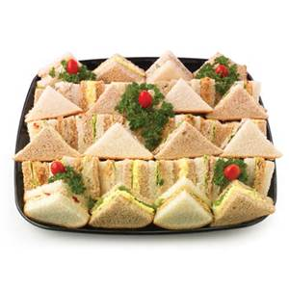 | Pizza with Carrot sticks | Mini Hot Dogs | Assortment of sandwiches with Cucumber sticks. | Cream of Tomato Soup and bread. | Scrambled egg Wraps
Pudding  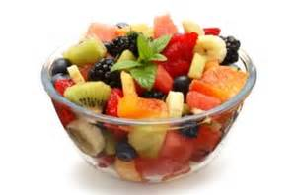 | Raisins. | Seasonal Fruit. | Raisins. | Seasonal Fruit. | Raisins.

Week 2 and 4
Time | Monday | Tuesday | Wednesday | Thursday | Friday
Snack  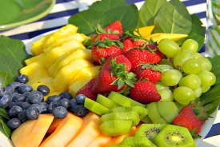 | Apple and Pear. | Crackers and cream cheese. | Cucumber and carrot sticks. | Grapes and orange segments. | Breadsticks and banana.
Lunch  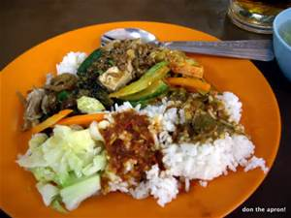 | Jacket potatoes, tuna and sweet corn. | Chicken Korma and rice. | Fish fingers, potatoes and hoops. | Lasagne and green beans. | Sausage, mash and green peas with gravy.
Veggie Option  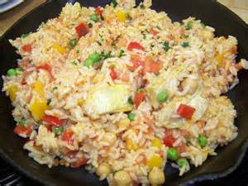 | Jacket potatoes, beans and cheese. | Quorn chicken korma and rice. | Veggie fingers, potatoes and hoops. | Quorn mince lasagne and green beans. | Quorn sausage, mash and peas with gravy.
Pudding  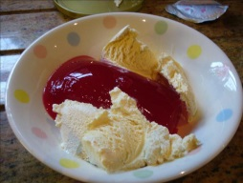 | Angle delight | Fromaige Freis | Melon | Banana and custard | Jelly and ice cream.
Snack  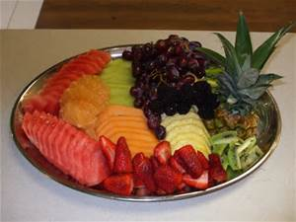 | Carrot and cucumber sticks. | Rice cakes and raisins. | Grapes and orange segments. | Breadsticks and banana. | Crackers and cream cheese.
Tea  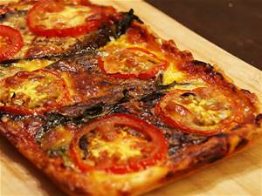 | Mini Sausage Rolls with Vegetable  sticks | Bagels with cheese and ham with Cucumber sticks | Scrambled Egg on Toast. | Assortment of Pitta pockets-Sandwiches. | Pizza with Carrot sticks
Pudding  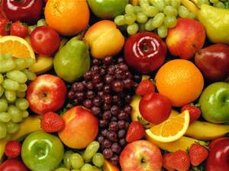 | Seasonal fruits. | Raisins | Seasonal fruits | Raisins | Seasonal fruits.

Breakfast
Choice of Cereal
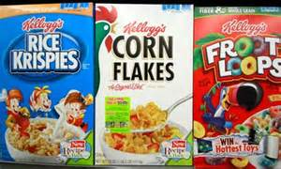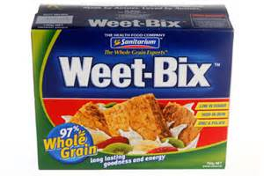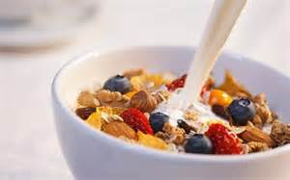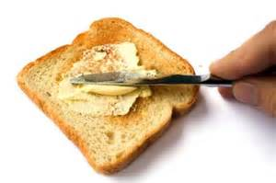
Choice of Fruit
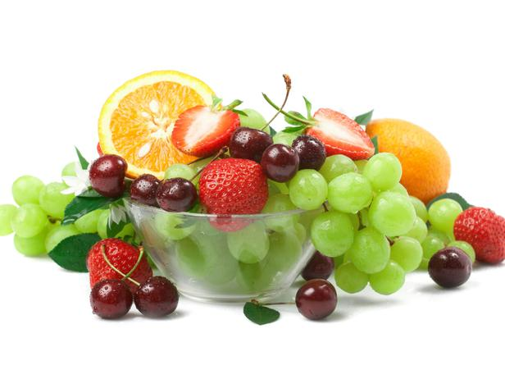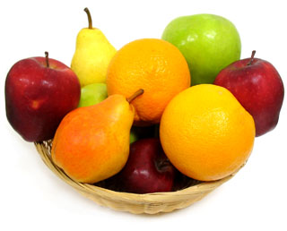

Toast

